Machine Learning Regression R² Value Report

# 1. Multiple Linear Regression

R² value = 0.9365

# 2. Support Vector Machine

|  |  |  |  |  |  |
| --- | --- | --- | --- | --- | --- |
| S.No | Hyper Parameter | Linear (R²) | RBF (Non-Linear R²) | Poly (R²) | Sigmoid (R²) |
| 1 | C10 | -0.0312 | -0.0480 | -0.0051 | -0.0536 |
| 2 | C100 | 0.6162 | -0.05097 | -0.0192 | -0.0356 |
| 3 | C500 | 0.6803 | -0.05097 | 0.1141 | 0.0738 |
| 4 | C1000 | 0.7894 | 0.00615 | 0.2669 | 0.1842 |
| 5 | C2000 | 0.8713 | 0.6460 | 0.4873 | 0.3976 |
| 6 | C3000 | 0.8956 | 0.1209 | 0.6377 | 0.0595 |

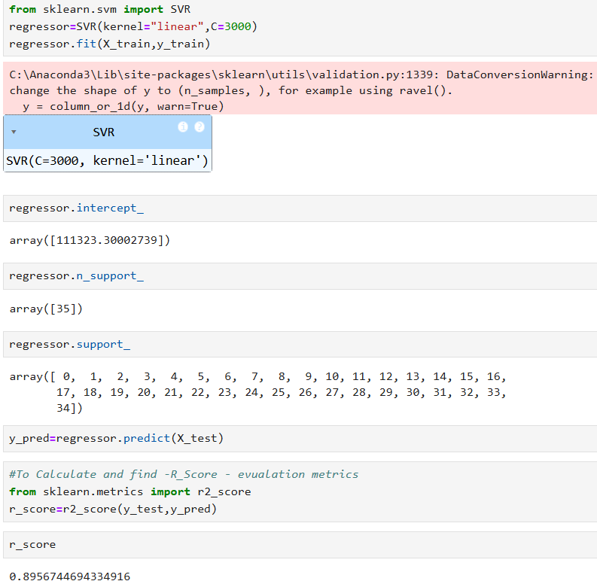

Best R²: 0.8609 using Linear kernel with C3000

# 3. Decision Tree

|  |  |  |  |
| --- | --- | --- | --- |
| **No** | **Criterion** | **Split** | **R² Score** |
| 1 | Friedman mse | Best | 0.9 |
| 2 | Squared error | Best | 0.93 |
| 3 | Absolute error | Best | 0.95 |
| 4 | Poisson | Best | 0.92 |
| 5 | Friedman mse | Random | 0.92 |
| 6 | Squared error | Random | 0.86 |
| 7 | Absolute error | Random | 0.86 |
| 8 | Poisson | Random | 0.95 |

Best R²: 0.95 using Absolute error with Best